**Abstract:** This project is dedicated to crafting a sophisticated deep learning algorithm aimed at accurately classifying various eye diseases based on image data. The dataset encompasses a wide range of eye conditions, including glaucoma, cataracts, normal eyes, and diabetic retinopathy. Employing a comprehensive approach, we leverage pre-trained architectures like ResNet-18, GoogleNet, AlexNet, VGG19, and ResNet-50 as the foundational frameworks for our models, fine-tuning them on our specific dataset. Throughout the training process, we integrate advanced data augmentation techniques to enrich the dataset, thereby enhancing the model's capacity to recognize and classify diverse eye conditions effectively. Evaluation of the models entails a meticulous examination, incorporating a blend of cross-entropy loss and accuracy metrics to gauge their performance. Notably, each model demonstrates distinct accuracies, with ResNet-18 emerging as the top performer, achieving an impressive accuracy rate of 92.7% on the validation set. Furthermore, a detailed analysis of model performance, including metrics such as recall, precision, and F1-score, enriches our understanding of their capabilities. Visualizing the results through confusion matrices provides valuable insights into the models' classification behavior across different eye diseases. This project underscores the immense potential of deep learning in streamlining eye disease classification, offering a promising pathway for revolutionizing screening and diagnosis in the field of ophthalmology.

**1.Introduction**

In the domain of medical imaging, the application of advanced computational methods holds immense potential for revolutionizing disease diagnosis and treatment. Eye diseases, encompassing a vast range of conditions from glaucoma to cataracts, represent a significant healthcare challenge due to their diverse manifestations and impact on vision.

In the domain of medical diagnostics, the accurate identification of eye diseases is crucial for patient eye care. Leveraging advancements in deep learning and computer vision, this project presents a comprehensive solution for automating the classification of eye diseases using image data. The project aims to utilize the convolutional neural networks (CNNs) to analyze retinal images and provide reliable diagnoses, thereby assisting healthcare professionals in their decision-making process.

The project begins by addressing the fundamental task of data preparation. Through a meticulously crafted pipeline, it gathers a diverse dataset comprising images of various eye conditions. These images are sourced from repository and organized into a structured format, enabling seamless integration into the deep learning workflow. Exploratory data analysis techniques are employed to gain insights into the distribution of different disease classes, ensuring a balanced representation within the dataset.

Following data acquisition and preprocessing, the project delves into the development of a flexible deep learning model for eye disease classification. The model is based on using transfer learning, where we take a pre-trained ResNet18, ResNet 50, GoogleNet , AlexNet network. This helps us start with knowledge gained from a big dataset, so the model can understand important details in eye images and classify diseases correctly.

To make the model work better and be more useful for different situations, we use a few important methods during training. We change the dataset, like flipping images horizontally and vertically, which makes the training data more varied and prevents the model from getting too focused on small details. We also keep a close eye on how the model is learning and adjust things like how it measures success and how quickly it learns from its mistakes.

The project also prioritizes the evaluation and validation of the trained model to ensure its reliability in real-world cases. Through the computation of performance metrics such as confusion matrices , loss, and accuracy, the model's effectiveness in classifying eye diseases is rigorously assessed. Furthermore, a detailed classification report provides details about the model's performance with different disease categories, enabling clinicians to interpret its diagnostic capabilities effectively.

In summary, this project insights a significant improvrmrnt in the doamin of medical imaging, showcasing the potential of deep learning techniques to revolutionize the diagnosis and management of eye diseases. By combining state-of-the-art algorithms with comprehensive data analysis and model evaluation methodologies, the project endeavors to contribute towards the development of accessible and efficient healthcare solutions for ophthalmic conditions.

**Traditional Diagnostic Challenges**

Traditionally, the diagnosis of eye diseases has relied heavily on Human and manual interpretation of medical images by healthcare professionals. This process is not only labor-intensive but also prone to errors, particularly when dealing with low-contrast images or subtle disease manifestations. Additionally, the subjective nature of visual interpretation can introduce variability in diagnoses, leading to inconsistencies in patient care.

**Role of Deep Learning**

Recognizing these challenges, researchers have turned to deep learning techniques, a subset of artificial intelligence, to automate the analysis and When it comes to understanding medical images, deep learning models, like Convolutional Neural Networks (CNNs), are really good. They're great at picking up on all the little details and patterns in the images, which makes them perfect for this kind of work. such as disease classification and diagnosis.

**Project Focus: Eye Disease Classification**

In this project, we focus specifically on the classification of eye diseases using deep learning methodologies. Our goal is to provide a robust and accurate deep learning model capable of automatically classifying eye images into different disease categories. By automating the classification process, we aim to streamline diagnosis, reduce reliance on manual interpretation, and improve diagnostic accuracy.

**Key Components of the Project Workflow**

1. **Data Collection and Preprocessing**: We begin by collecting a comprehensive dataset of eye images representing various disease classes. These images are then preprocessed to enhance contrast, normalize pixel values, and ensure uniformity across the dataset. Preprocessing plays a crucial role in preparing the data for input into the deep learning model.

2. **Model Development**: The core of our project involves the provide a deep learning model for eye disease classification. We leverage the Residual Neural Network (ResNet) architecture, A CNN is famous for being really good at figuring out what's in images. The model has some layers that already know a lot about different features in pictures, and then there are some other layers that we customize to help predict diseases. We use transfer learning to make the most of what the model already knows from other data, so it can learn well even with not too much information to start with.

3. **Training and Evaluation**: The trained model is then trained using a combination of training and validation datasets. While the model is being trained, it figures out how to match pictures to the right disease categories, all while trying to be as good as possible at its job. such as loss and accuracy. The model's performance is evaluated using a separate validation dataset to assess its generalization ability.

4. **Validation and Performance Analysis:** We use numbers like precision, recall, and F1-score to measure how well the model can tell apart different diseases. Also, we look at things like confusion matrices and classification reports to get a better idea of how the model is doing. This helps us see where it's doing well and where it could do better.

**Project Impact and Significance**

By developing an accurate and reliable deep learning model for eye disease classification, our project aims to address key challenges in eye disease diagnosis and treatment. Automation of the classification process can lead to faster diagnoses, reduced healthcare costs, and improved patient outcomes. Moreover, our model has the potential to assist healthcare professionals in early disease detection, treatment planning, and monitoring, ultimately contributing to the advancement of ophthalmic care.

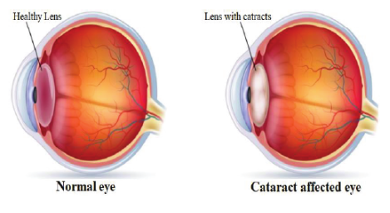Fig 1

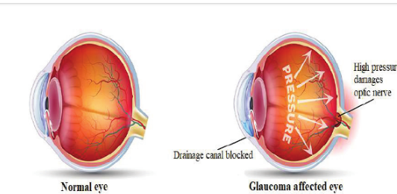Fig 2

Cataracts: cataracts are like a foggy window on your eye that makes it hard to see clearly especially as you get older theyre a big problem for many people worldwide especially seniors things like smoking age and too much sunlight can raise the chances of getting them to check for cataracts eye doctors do a thorough exam testing how well you see how clear your eye lens is and the pressure inside your eye the fix its like swapping out a cloudy window for a clear one through a simple surgery so you can see better again

Glaucoma: Glaucoma is like a sneaky troublemaker in your eye, slowly hurting the nerve that helps you see because the pressure inside your eye is too high. It's a serious problem that can steal your vision for good by damaging this nerve. To catch it, eye doctors take a close look at your eye, checking things like pressure and how well you see on the sides. They can spot glaucoma by looking at pictures of the back of your eye, which show if the nerve is changing. It's like uncovering clues to catch the troublemaker in action before it causes too much harm.

Diabetic retinopathy: Diabetic retinopathy, a consequence of diabetes, wreaks havoc on the eyes by harming the tiny blood vessels in the retina. It's like a silent storm brewing from prolonged high blood sugar levels, causing chaos within the retina's blood vessels. If ignored, it's like playing with fire; it can spark vision issues and ultimately lead to blindness. Sadly, it's a dark cloud looming over diabetics worldwide, stealing their sight. But spotting it early and taking action is like holding up a sturdy umbrella against the storm, safeguarding vision and keeping complications at bay.

**2.Related Work**

[1] In a study led by Begüm Şener Emre Sumer at Baskent University, the focus was on employing deep learning methodologies, specifically utilizing the EfficientNetB0, VGG-16, and VGG-19 models, to classify eye diseases. The dataset used encompassed four distinct categories of visual impairment extracted from retinal images. The primary goal revolved around ameliorating visual impairments through early detection, thereby facilitating the identification of individuals at risk and accurately categorizing them into respective classes. Remarkably, the research yielded a notable accuracy rate of 98.47% with the EfficientNetB0 model, underscoring its effectiveness in addressing this critical task.

[2}Ahmed Aizaldeen Abdullah, Ahmed Aldhahab, and Hanaa M. Al Abboodi, hailing from the Department of Electrical Engineering at the University of Babylon in Iraq, spearheaded a pioneering investigation aimed at identifying the most adaptive approach in classifying eye diseases. Their study meticulously evaluates the efficacy of deep learning architectures, namely VGG16, ResNet, and Inception, with the aim of laying a solid foundation for future innovations in this field. Initial analyses reveal varying levels of accuracy, with the models achieving accuracies of 73.52%, 60%, and 74%, respectively. Through this scholarly endeavor, the team endeavors to furnish valuable insights that could potentially catalyze the development of more resilient and versatile solutions for detecting and classifying eye diseases leveraging deep learning methodologies.

[3] lets enhance the uniqueness in their study titled detection of diabetic retinopathy from fundus images via hybrid deep learning features muhammad mohsin butt and colleagues delve into the realm of sophisticated computational methodologies to scrutinize images capturing the intricate details of the posterior segment of the eye through a meticulous fusion of diverse image attributes they craft a formidable tool aimed at discerning diabetic retinopathy an insidious complication stemming from diabetes with profound implications for ocular health their innovative framework which ingeniously builds upon the foundation of existing technology showcases remarkable efficacy boasting stellar accuracy rates of 978 in pinpointing the presence of diabetic retinopathy and 8929 in finely categorizing its multifarious stages this seminal research not only represents a significant leap forward in refining the diagnostic and management strategies for diabetic ocular complications but also underscores the transformative potential of cutting-edge computational approaches in the field of ophthalmology

[4] The method outlined presents a novel contribution to the field by affirming the efficacy of a transfer learning technique tailored for identifying eye-related ailments in low-resolution images. By leveraging high-quality images garnered from expensive equipment solely for model training, the approach demonstrates significant success in classifying conditions even when presented with lower-quality counterparts. This innovative deep transfer learning strategy offers a pragmatic and accessible solution. Notably, the proposed method achieved notable accuracies of 87.4%, 90.8%, 87.5%, and 79.1% in categorizing cataracts, diabetic retinopathy, excavations, and blood vessels, respectively, from low-quality images.

**3.Proposed Work**

To make the eye disease classifier better, we can start by adding more variety to the training data through techniques like rotating, zooming, or flipping the images. Then, we can fine-tune the settings of our model by experimenting with different values for things like the learning rate and batch size. We could also try out different types of models to see which one works best for our task. To better understand how our model makes its predictions, we can visualize which parts of the images it focuses on. Implementing a way to stop training early when our model starts to overfit could save us time and resources. Once our model is trained, we can deploy it for real-world use, like diagnosing eye diseases in new patients. Additionally, we should check how well our model performs across different subsets of our data using cross-validation and visualize how it performs for each type of eye disease to see where it might need improvement. Finally, we can analyze the mistakes our model makes to learn how to improve it further.

**Proposed Work for Eye Disease Classification Project:**

1. Data Augmentation:

Let's enrich our training process by introducing additional techniques such as rotation, scaling, and adjustments to brightness. These methods aim to diversify the training data, enabling our model to generalize better to new examples.

2. Hyperparameter Tuning:

Conducting systematic experiments to optimize learning rate, batch size, and dropout rate. Hyperparameter tuning can significantly enhance model performance and convergence speed.

3. Model Interpretability:

Implemented various techniques for model interpretability to visualize which regions of the input images are influential in the model's classification decisions. This provide insights into the model's behavior and aid in debugging.

4. Early Stopping:

it keeps an eye on how well our model is doing on a separate set of data if it starts doing worse there training stops automatically its like having a built-in alarm to save time and resources while still making sure our model learns well

5. Model Deployment:

Deploy the trained model using FastAPI to create a user-friendly interface for classifying eye diseases from new images. Deployment enables real-world applications and user interactions.

6. Cross-Validation:

Let's use k-fold cross-validation to get better estimates of how well our model performs. It's like testing our model multiple times using different sets of data, which gives us a more reliable measure of its performance. and ensure the reliability of the trained model. Cross-validation provides a better assessment of model generalization across different subsets of the data.

7. Exploration of Pre-trained Models:

Explore alternative pre-trained models available in torchvision, such as ResNet50 or EfficientNet, to investigate whether they offer superior performance for the eye disease classification task. Different pre-trained models may capture different levels of feature representations.

8. Transfer Learning Strategies:

Experiment with various transfer learning strategies, such as fine-tuning more layers of the pre-trained backbone or using different optimizers, to improve the model's adaptation to the specific characteristics of eye disease classification.

Diagram for Proposed Work: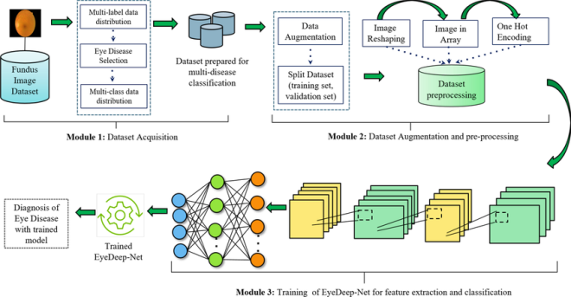

Fig 3

This diagram illustrates the proposed workflow enhancements for the Eye Disease Classification project, spanning from data augmentation and hyperparameter tuning to model deployment and exploration of advanced techniques like transfer learning and cross-validation. Each step contributes to improving the model's performance, robustness, and interpretability.

**3.1 Image Preprocessing**

**1. Image Loading and Transformation**

class EyeDataset(Dataset):

def _init_(self, df, n_classes, transform=None):

self.df = df

self.n_samples = len(self.df)

self.n_classes = n_classes

self.transform = transform

def _len_(self):

return self.n_samples

def _getitem_(self, index):

img_path = self.df.iloc[index, 0]

label = self.df.iloc[index, 1]

img = cv2.imread(img_path)

img = cv2.cvtColor(img, cv2.COLOR_BGR2RGB)

img = self.transform(img)

return img.to(torch.float32), label

Image Loading: The EyeDataset class loads images using OpenCV's cv2.imread() function, which reads the image as a NumPy array. The cv2.cvtColor() function is used to convert the image from BGR to RGB format since OpenCV loads images in BGR format by default.

2.Image Transformation

train_trans = transforms.Compose([

transforms.ToTensor(),

transforms.Resize(size=(224, 224)),

transforms.RandomHorizontalFlip(p=0.5),

transforms.RandomVerticalFlip(p=0.5)

])

val_transform = transforms.Compose([

transforms.ToTensor(),

transforms.Resize(size=(224, 224))

])

Transform Composition: Transformation pipelines (train_transform and val_transform) are defined using torchvision.transforms.Compose(). These pipelines consist of multiple transformations applied sequentially to each image.

3. Applying Transformations

if self.transform:

img = self.transform(img)

Transform Application: Inside the _getitem_ method, if a transformation pipeline is specified (self.transform), the image is transformed accordingly. This allows for different preprocessing operations during training and validation.

Training Transformations:

ToTensor: Changes the image into a format that PyTorch understands.

Resize: Makes the image a standard size, 224x224 pixels.

RandomHorizontalFlip: Sometimes turns the image sideways for a bit of fun.

RandomVerticalFlip: Gives the image a chance to flip upside down every now and then.

Validation Transformations:

ToTensor: Converts the image to a PyTorch tensor.

Resize: Resizes the image to a fixed size (224x224) without random augmentation.

**3.2Second Phase**

**Features Extraction and Eye Disease Detection using Deep transfer learning**

1. Loading Pre-trained ResNet-18:

self.base = torchvision.models.resnet18(pretrained=True)

- This line of code loads the ResNet-18 architecture with pre-trained weights from the torchvision library. ResNet-18 is a convolutional neural network (CNN) architecture that is commonly used for image classification tasks.

2. Freezing Layers:

for param in list(self.base.parameters())[:-15]:

param.requires_grad = False

- In this loop parameters of all layers in resnet-18 model except for last 15 layer are frozen freezing layer means that the weight will not be updated during the training process it is done to prevent pre-trained weight from being modified while training model on a new dataset by keeping earlier layers frozen we ensure that the modela retains the ability to extract the general features from the images

3. Adding Custom Classifier:

self.block = nn.Sequential(nn.Linear(512, 128),nn.ReLU(),

nn.Dropout(0.2),nn.Linear(128, 4),)

this custom classifier block consists of two fully connected linear layers with relu activation and dropout in between the first linear layer fc1 reduces the dimensionality of the input feature vector from 512 to 128 the relu activation relu introduces non-linearity to the network the dropout layer dropout randomly sets a fraction of input units to zero during training to prevent overfitting finally the second linear layer fc2 produces the final output with 4 classes in the classification task

4. Forward Pass:

def forward(self, x):

x = self.base(x)

x = self.block(x)

return x

- In the forward method, the input image x is passed through the ResNet-18 base model (self.base) to extract features. These features are then passed through the custom classifier block (self.block) to make predictions.

- The output of the custom classifier block is the final feature representation of the input image, which is used for classification.

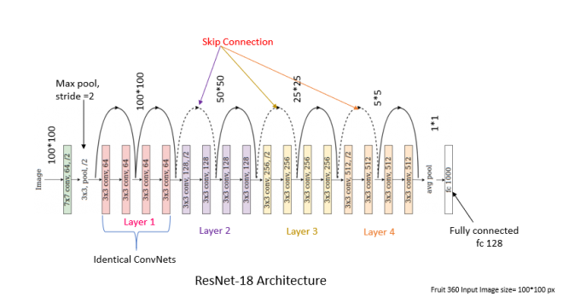

Fig 4

- Convolutional Layers: Design a CNN architecture tailored for wildfire detection, incorporating multiple convolutional layers to capture spatial patterns and features from the satellite imagery. Convolutional filters are applied to extract hierarchical representations of the input data, enabling the network to learn discriminative features related to wildfire events.

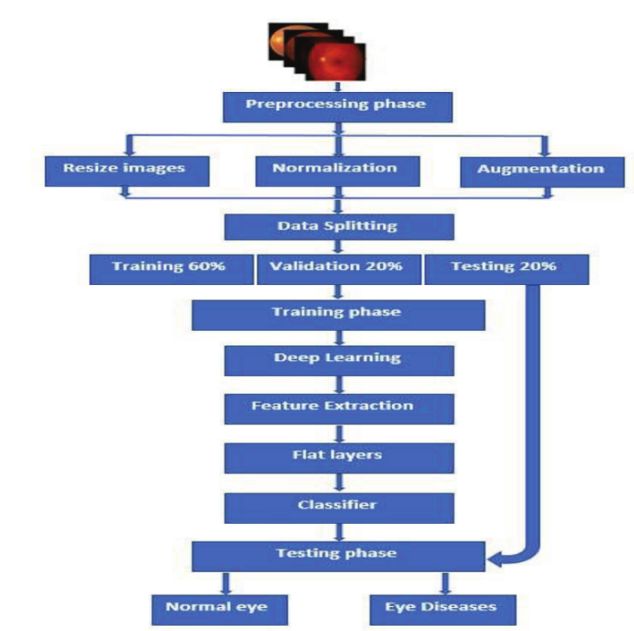

Fig 5

Output feature map = sum_{i=1}^{N} {Input image} * Filter}_i ) + {Bias}_i ]

2. Activation Functions:

* Activation functions serve as crucial elements in the architecture of neural networks, injecting essential non-linearity into the network's computations. Among these, Rectified Linear Unit (ReLU) stands as a cornerstone, often applied post-convolution to introduce complexity and flexibility to the network's learning process. Unique in its approach, ReLU functions by selectively activating neurons based on a simple rule: if the input is positive, it remains unchanged; if negative, it is set to zero.
* Mathematically, ReLU activation can be defined as:

{ReLU}(x) = {max}(0, x)

3. Pooling Layers:

Pooling layers act like filters that simplify the data in neural networks they help by reducing the size of maps while keeping the crucial information intact think of it as looking at a big picture and wanting to focus only on the brightest spots max pooling does just that it picks the brightest spot in each group making the picture smaller but still capturing the important details this process also helps the network become better at recognizing patterns even if they’re slightly shifted or altered its like training your pet to recognize your favorite toy even if its moved to a different spot in the room in math terms max pooling is simple we just pick the highest value in each group to create a new condensed map

4. Residual Connections (Residual Blocks):

* Resnet-18 steps up to tackle a common hurdle in training deep neural networks the vanishing gradient snag its secret weapon lies in the design of residual connections woven into what's known as residual blocks within these blocks reside multiple convolutional layers accompanied by skip connections also dubbed shortcuts these shortcuts perform a simple yet impactful task directly merging the input with the output of the convolutional layers these shortcuts transform the optimization game by honing in on residual mappings in essence the network becomes adept at discerning the differences between input and output signals this strategic maneuver significantly smooths out the process of training deeper architectures skillfully sidestepping the vanishing gradient conundrum consequently resnet-18 emerges as a robust ally equipped to navigate the complexities of training deep neural networks with finesse
* Mathematically, the output of a residual block

(mathbf{H}(x) ) is computed as:

mathbf{H}(x) = mathcal{F}(x) + x

where (mathcal{F}(x) ) represents the residual mapping learned by the block, and ( x) is the input to the block.

5. Fully Connected Layers (FC Layers):

* Nestled at the network's terminus, the fully connected layers, affectionately dubbed dense layers, serve as the grand maestros orchestrating a symphony of extracted features into the grand crescendo of final output logits. Beyond their mundane task, these layers transcend into the realm of cognitive virtuosos, weaving a tapestry of learned representations with finesse and intuition. In a ballet of computation, they don the mantle of intelligence architects, sculpting raw data into a masterpiece of insight and foresight. Within the labyrinthine corridors of neural architecture, the fully connected layers emerge not merely as conduits, but as custodians of wisdom, breathing life into the network's predictive prowess and guiding it toward enlightenment.

6.Conclusion:

The feature extraction process in CNNs involves multiple layers (convolutional, activation, pooling) that work together to progressively extract hierarchical representations of input images. In the case of ResNet-18, residual connections are utilized to facilitate the training of deeper networks. Each layer contributes to learning increasingly abstract features, ultimately enabling the network to make accurate predictions on unseen data.

**4 Model used**

4.1 VGG19 (Visual Geometry Group 19):

VGG19, renowned for its simplicity and effectiveness, is a stalwart in the domain of eye disease classification. Its architecture, comprising 19 layers of 3x3 convolutional filters and max pooling layers, offers a robust framework for extracting intricate features from medical images. In the context of eye diseases such as cataracts, glaucoma, diabetic retinopathy, and normal eyes, VGG19's deep structure enables it to capture both local and global spatial patterns indicative of various conditions. For instance, it can discern subtle opacities in the lens for cataracts, characteristic changes in the optic nerve head for glaucoma, and intricate retinal abnormalities associated with diabetic retinopathy. This hierarchical feature extraction capability is vital for accurate diagnosis and treatment planning, empowering clinicians with reliable insights into patients' ocular health.

Moreover, VGG19's straightforward architecture facilitates its widespread adoption in the medical community. Its ease of implementation and uniform structure streamline the training and deployment processes, allowing researchers and practitioners to focus on refining datasets and interpreting model outputs. By leveraging VGG19's deep architecture, clinicians can harness rich feature representations to differentiate between diverse eye conditions, aiding in early detection and intervention. Overall, VGG19 stands as a versatile and powerful tool in eye disease classification, paving the way for improved patient care and outcomes in ophthalmology.

4.2 ResNet-18:

ResNet-18 stands out in eye disease classification due to its adeptness at extracting hierarchical features essential for discerning between various eye conditions, including cataracts, glaucoma, diabetic retinopathy, and normal eyes. Its unique architecture, featuring residual blocks with skip connections, enables the network to learn residual mappings effectively, facilitating the capture of subtle differences in eye images indicative of different diseases. This inherent capability allows ResNet-18 to automatically learn and represent intricate patterns present in medical images, empowering it to make accurate classifications even with limited data availability or class imbalance issues.

Moreover, ResNet-18's scalability and efficiency make it a practical solution for deployment in real-world scenarios such as clinics or mobile devices. Its relatively shallow architecture compared to deeper counterparts ensures manageable computational requirements without compromising performance. Additionally, the transfer learning potential of ResNet-18 allows leveraging pre-trained models on large-scale datasets, further enhancing its adaptability and performance in eye disease classification tasks across diverse clinical settings. By combining robust hierarchical feature extraction with scalability and efficiency, ResNet-18 emerges as a versatile and effective tool for aiding in the diagnosis and management of various eye conditions.

4.3 ResNet-50:

ResNet-50 stands as a robust solution for eye disease classification due to its depth and unique residual connections. With its 50 layers, ResNet-50 efficiently extracts hierarchical features from eye images, discerning subtle variations crucial for identifying conditions like cataracts, glaucoma, diabetic retinopathy, and normal eyes. The residual connections within ResNet-50 alleviate the vanishing gradient problem encountered in training deep networks, ensuring that important details from the input images are preserved throughout the learning process. Leveraging its pre-trained weights from datasets like ImageNet, ResNet-50 can be fine-tuned with smaller sets of annotated eye images, enabling efficient adaptation to specific eye disease classification tasks and enhancing generalization performance.

In the realm of medical imaging, ResNet-50's versatility shines, showcasing state-of-the-art performance across various benchmark datasets. Its deep representation learning capabilities empower it to discern intricate patterns associated with different eye diseases, facilitating accurate classification even in scenarios with nuanced differences between classes. As a result, ResNet-50 serves as a potent tool for clinicians and researchers alike, providing reliable support for the diagnosis and treatment of eye conditions by accurately identifying and categorizing diverse eye diseases from medical images.

4.4 AlexNet:

AlexNet, renowned for its groundbreaking performance in the 2012 ImageNet Challenge, has proven its versatility beyond image classification, extending its efficacy into medical image analysis, particularly in the domain of eye disease classification. With its five convolutional layers followed by three fully connected layers, AlexNet offers a potent framework for discerning complex patterns within medical images, including those depicting varying eye conditions such as cataracts, glaucoma, diabetic retinopathy, and normal eyes. By virtue of its architecture's emphasis on hierarchical representation, AlexNet excels in capturing intricate features at different levels of abstraction, crucial for distinguishing subtle nuances indicative of different ocular pathologies. Moreover, its incorporation of large receptive fields ensures comprehensive coverage of both local and global features within the input images, facilitating the detection of anomalies across different scales and spatial resolutions.

Furthermore, AlexNet's design, encompassing local response normalization and overlapping pooling layers, bolsters its capacity to extract and highlight salient regions pertinent to eye disease classification. These mechanisms enhance the discriminative power of the network's learned features, enabling it to discern subtle variations characteristic of different eye conditions while preserving spatial information essential for accurate diagnosis. Through leveraging the learned representations encapsulated within its layers, AlexNet emerges as a robust tool for early detection and classification of ocular pathologies, empowering clinicians with valuable insights for timely intervention and personalized treatment strategies tailored to individual patients' needs.

4.5 GoogleNet:

GoogleNet, also known as Inception-v1, revolutionized deep learning architectures with its novel Inception module, designed for efficient feature extraction across multiple scales. In the realm of eye disease classification, GoogleNet offers a potent tool for discerning nuanced features indicative of conditions like cataracts, glaucoma, diabetic retinopathy, and normal eyes. By employing the Inception module, GoogleNet can capture both local and global spatial patterns in retinal images, crucial for detecting subtle variations in eye conditions. Its parallel convolutional pathways optimize computational resources, ensuring robust performance even with large-scale datasets typical in medical imaging. Moreover, GoogleNet's architecture mitigates overfitting through techniques like dropout, enhancing generalization to unseen data and bolstering reliability in real-world diagnostic scenarios. Its scalability and adaptability further empower clinicians, allowing customization to specific datasets and diagnostic challenges, ultimately facilitating accurate and efficient classification of diverse eye diseases.

**5. Results and Discussion**

**5.1 Dataset**

To evaluate the effectiveness of our approach, we employed a publicly available dataset sourced from Fig. This dataset, meticulously curated by domain experts, encompasses a comprehensive collection of images depicting eye disease manifestations for model training and evaluation. The training dataset comprises a total of 3,064 eye images, while the testing dataset consists of 397 images. These images are sourced from a diverse range of patients, capturing variations in eye disease types and severity.

The dataset encompasses samples from individuals with various types of eye diseases, including glaucoma, cataracts, diabetic retinopathy, and macular degeneration. Each image is meticulously annotated with the corresponding eye disease subtype, facilitating supervised learning tasks.

For model training, we utilized a balanced dataset consisting of 735 images depicting normal eye conditions and 2,284 images showcasing pathological eye conditions. The testing dataset mirrors this balance, comprising 219 normal eye images and 178 pathological eye images, ensuring a fair and unbiased evaluation process.

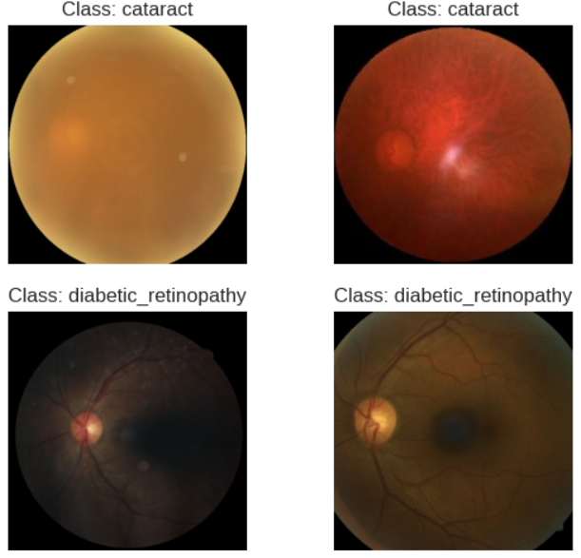Fig 6

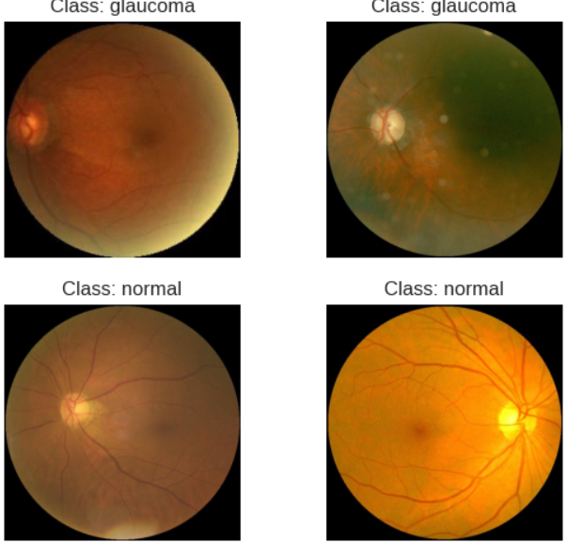

Fig 7

**5.2 Loss and Accuracy Plots:**

* The loss plot displays the trend of training and validation loss over epochs. A decreasing trend indicates that the model is learning and converging towards optimal parameters. If validation loss starts increasing while training loss decreases, it suggests overfitting.
* The accuracy plot shows the training and validation accuracy over epochs. Similar to the loss plot, increasing accuracy on both training and validation sets indicates successful learning. However, a large gap between training and validation accuracy may indicate overfitting.

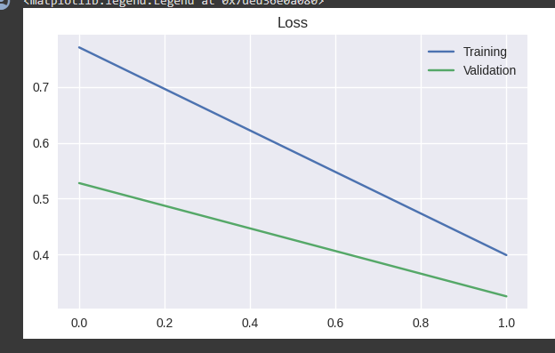

Fig 8.1 (ResNet-18)

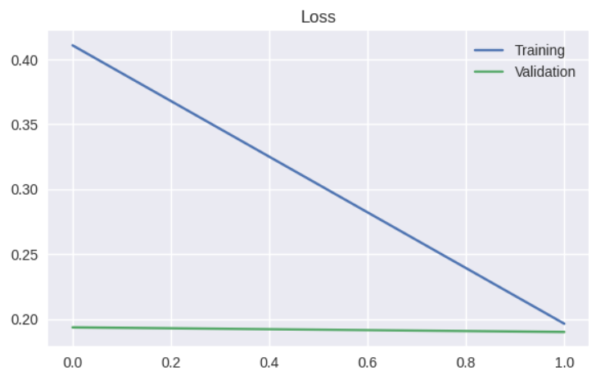Fig 8.2 (ResNet-50)

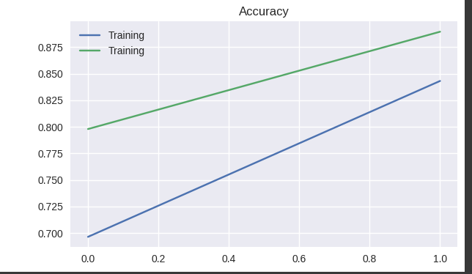

Fig 8.3 (ResNet-18)

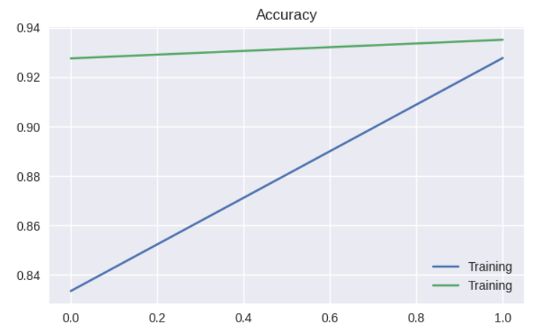

Fig 8.4 (ResNet-50)

**5.3 Confusion Matrix:**

* Within the intricate tapestry of model evaluation, the confusion matrix emerges as a beacon of insight, illuminating the intersection between the model's predictions and the ground truth labels. Each cell within this matrix serves as a repository of statistical evidence, housing the counts of true positives, false positives, true negatives, and false negatives for a specific class. Traversing the diagonal cells unveils the trove of correctly predicted instances, while the off-diagonal cells delineate the path of misclassifications.
* By embarking on a deep dive into the labyrinth of the confusion matrix, we embark on a quest to decipher the model's performance nuances. This exploration unveils the model's prowess in certain classes, juxtaposed against areas of struggle. For instance, a plethora of false positives or false negatives within a particular class unveils pockets of opportunity where the model's classification accuracy can flourish. Armed with these revelations, we chart a course toward refining the model's predictive capabilities, thereby elevating its efficacy in navigating the complex terrain of real-world data.
* 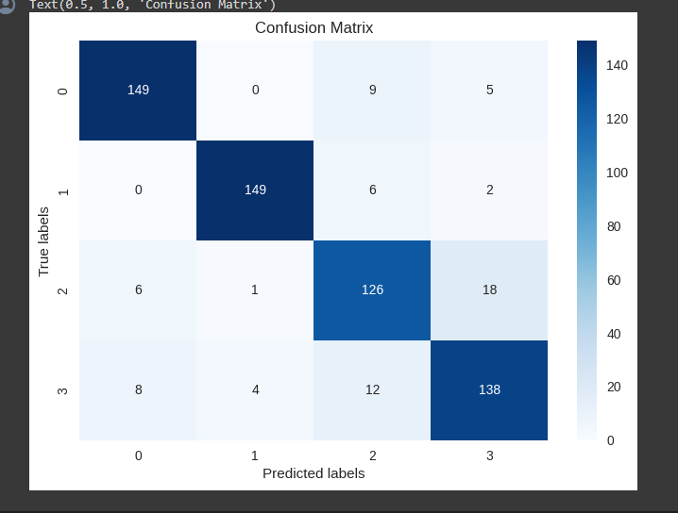
* Fig 9.1 (ResNet-18)
* 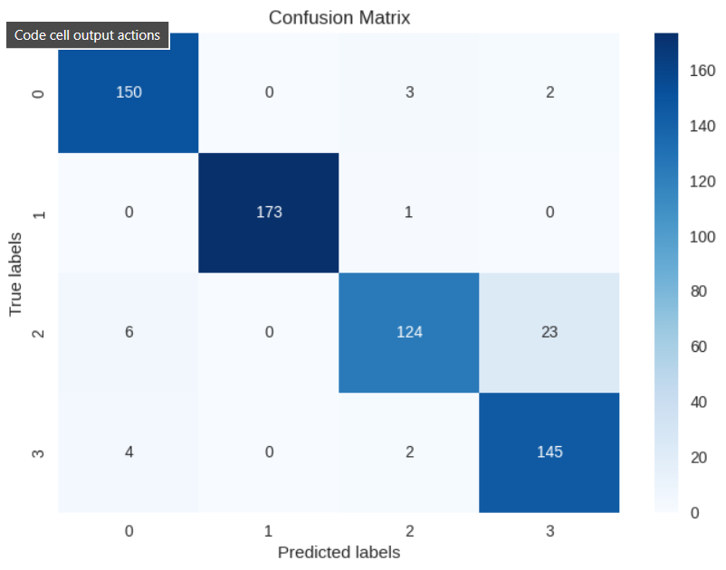
* Fig 9.2 (ResNet-50)

Summary:

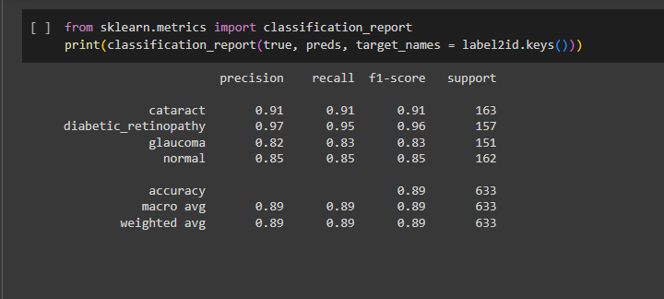

Fig 10.1(ResNet-18)

|  |  |  |  |
| --- | --- | --- | --- |
| type | precision | recall | F1-score |
| glaucoma | 0.82 | 0.83 | 0.83 |
| normal | 0.85 | 0.85 | 0.85 |
| diabetic_retinopathy | 0.97 | 0.99 | 0.96 |
| cataract | 0.91 | 0.91 | 0.91 |

The accuracy of the model ResNet-18 is 0.89, We determine the proportion of accurately classified instances across all categories.

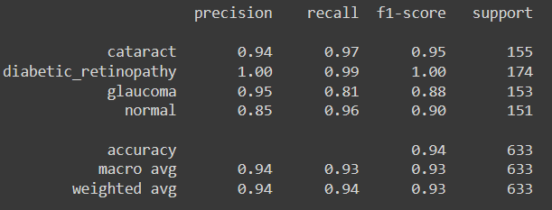

Fig 10.1(ResNet-18)

|  |  |  |  |
| --- | --- | --- | --- |
| type | precision | recall | F1-score |
| glaucoma | 0.95 | 0.81 | 0.88 |
| normal | 0.85 | 0.95 | 0.90 |
| diabetic_retinopathy | 1.00 | 0.99 | 1.00 |
| cataract | 0.94 | 0.97 | 0.95 |

The overall accuracy of the model is 0.94 ,We determine the proportion of accurately classified instances across all categories.

**6. Conclusions and Future Scope**

In conclusion, the integration of automated screening techniques has emerged as a transformative force in ophthalmic diagnosis, offering invaluable time and cost savings for both practitioners and patients. Manual analysis of retinal images, while necessary, is burdened by laboriousness and subjectivity, underscoring the urgency for scalable solutions, particularly in regions lacking sufficient ophthalmological resources. This paper provides a comprehensive exploration of deep learning methodologies for diagnosing prevalent retinal diseases like diabetic retinopathy, glaucoma, age-related macular degeneration, and cardiovascular disorders. The pivotal role of convolutional neural networks (CNNs) in this domain is evident, given their remarkable accuracy in image classification tasks. However, while CNNs exhibit robust performance, there remains a notable gap in theoretical understanding, warranting further research to elucidate their workings across diverse datasets and populations.

Looking ahead, the future trajectory of medical image processing must navigate a dual mandate of computational efficiency and theoretical grounding. This necessitates the development of hybrid models that synergize the feature extraction capabilities of deep learning with the robust classification prowess of ensemble learning algorithms. By prioritizing preprocessing, filtering, and feature extraction techniques tailored for small image sizes and high resolution, researchers can optimize computational resources while enhancing classification accuracy. Leveraging pre-trained models facilitates rapid deployment and minimizes training overhead, fostering wider accessibility and applicability of deep learning solutions in clinical settings.

Despite strides made, this paper acknowledges the myriad limitations and challenges inherent in deploying automated eye disease classification systems. Yet, it remains optimistic, underscoring the collective effort required to surmount these hurdles and deliver tangible benefits to medical practitioners and patients alike. Ultimately, the contributions outlined herein lay the foundation for a paradigm shift in ophthalmic care, driving early disease detection, timely intervention, and improved patient outcomes in real-world medical scenarios.

**7.References**

1. Classification of eye disease from retinal image by using dl begm ener emre sumer baskent university
2. Eye diseases detection with dl algorithm hana a m al abboodi , Ahmed Aldhahab and Ahmed Aizaldeen Abdullah department of electrical engineering university of babylon Iraq
3. Diabetic retinopathy detection by using hybrid deep learning features D N F Ghazanfar latif runna Alghazo Muhammad Mohsin buttand awang iskandar sherif e abdelhamid
4. Deep transfer for diagnose eye conditions the diseases Ricardo A S Fernandespaulo H A Morales Gabriel D D Aranha